

**MATHEMATICS DEPARTMENT**

**MATHEMATICAL METHODS YEAR 12 – TEST 5**

DATE: 7th September 2016 Name:_________________________

**Reading Time:** 3 minutes

**SECTION ONE: CALCULATOR FREE**

WORKING TIME: Maximum 27 minutes

TOTAL: 27 marks

EQUIPMENT: pens, pencils, pencil sharpener, highlighter, eraser, ruler, formula sheet (provided)

**SECTION TWO: CALCULATOR ASSUMED**

WORKING TIME: Minimum 23 minutes

TOTAL: 23 marks

EQUIPMENT: pens, pencils, pencil sharpener, highlighter, eraser, ruler, drawing instruments, templates, up to 3 calculators, formula sheet (provided) one A4 page of notes (one side only)

|  |  |  |  |  |  |
| --- | --- | --- | --- | --- | --- |
| **Question** | **Marks available** | **Marks awarded** | **Question** | **Marks available** | **Marks awarded** |
| 1 | 9 |  | 5 | 4 |  |
| 2 | 7 |  | 6 | 11 |  |
| 3 | 11 |  | 7 | 8 |  |
|  |  |  |  |  |  |
| **Sect 1 Total** | **27** |  | **Sect 2 Total** | **23** |  |
|  |  |  | **TOTAL** | **50** |  |

**Question 1 (9 marks)**

(a) For  , find (3 marks)

(b) Let  .

(i) Find  (1 mark)

**Question 1 continued over page…**

**Question 1 continued…**

(ii) The following diagram shows part of the graph of .

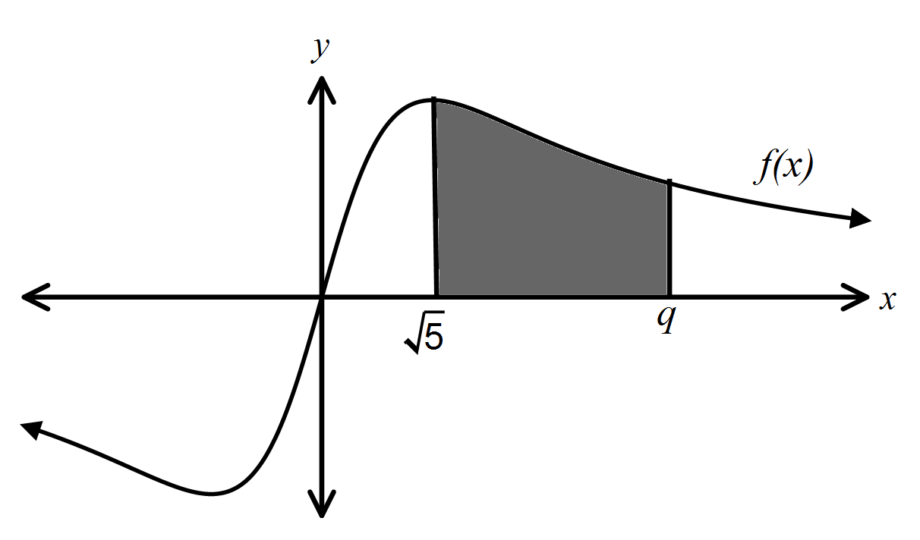

The shaded region is enclosed by the graph of , the -axis, and the lines  and .

This region has an area of square units.

Find the value of . (5 marks)

**Question 2 (7 marks)**

For the graph of 

(a) find the equation of the vertical asymptote, (1 mark)

(b) find the - intercept, (2 marks)

(c) circle the range the - intercept falls within, (1 mark)

-1-0.5 -0.50 00.5

0.51 11.5 1.52

(d) sketch the graph on the axes below. (3 marks)

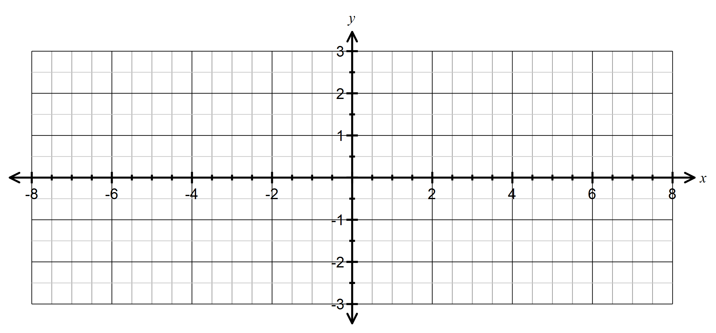

**Question 3 (11 marks)**

Let , for .

Let . The following diagram shows parts of the graph of  and .

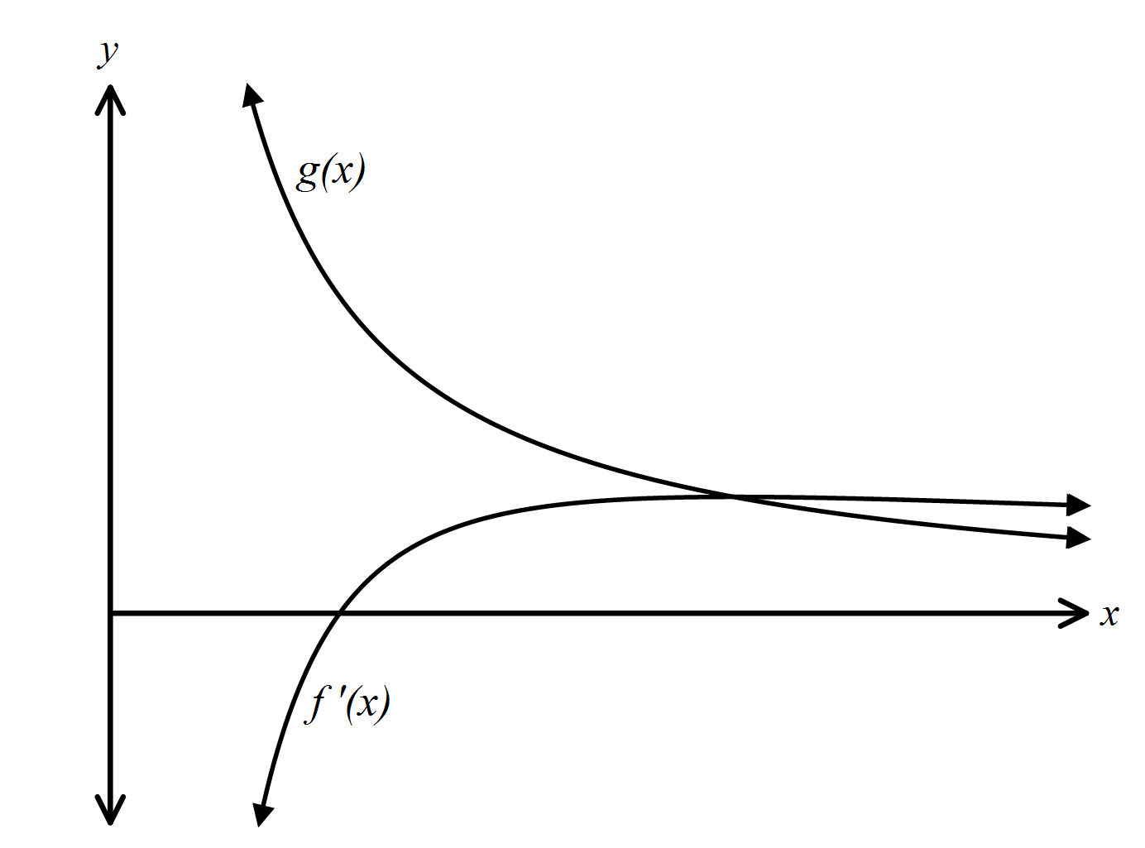

The graph of has an -intercept at 

(a) Show that . (2 marks)

(b) There is a minimum on the graph of . Find the -coordinate of this minimum. (2 marks)

(c) Write down the value of . (1 mark)

**Question 3 continued over page…**

**Question 3 continued…**

(d) The graph of  intersects the graph of  when 

(i) Find the value of . (2 marks)

(ii) Let  be the region enclosed by the graph of , the graph of  and the line 

Find the area of  (4 marks)

**End of Section One**

**Section Two: Calculator Assumed Name: ___________________**

**Question 4 (4 marks)**

In a survey of 400 Australian females aged between 12 and 18 years it was found that 35% of the

respondents think that their Maths teachers are funny.

(a) According to the results of this survey complete the following statement (give percentages to nearest whole percent).

*We can be 97.5% confident that of all Australian females between the ages of 12 and 18, between*

*________% and ________% think that their Maths teachers are funny.* (2 marks)

(b) If the confidence interval described in (a) was reduced in size, would this increase **or** decrease our confidence that the proportion of all Australian females between the ages of 12 and 18 think that their Maths teacher is funny fits within the new confidence interval?

Explain your answer. (2 marks)

**Question 5 (11 marks)**

The quality manager at Stewies’ Fortune Cookie Company believes that a larger than acceptable proportion of paper fortunes being used are blank.

(a) Suppose she takes a sample of 640 fortune cookies from the production line, and 30 of the paper fortunes are blank.

(i) Can the distribution of the sample proportions be accurately modelled by a Normal Distribution? Justify your answer. (2 marks)

(ii) Calculate the sample proportion, **, of those sampled which were blank. (1 mark)

(iii) Estimate the standard deviation of the random variable *,* for such samples of size 640.

(2 marks)

**Question 5 continued over page…**

**Question 5 continued…**

(b) Suppose another sample of 520 fortune cookies was taken. If the true proportion of fortunes that were blank is 0.02, what is the probability that:

(i) the sample proportion is at most 0.03? (4 marks)

(ii) at least 1.5% of the fortunes are blanks (2 marks)

**Question 6 (8 marks)**

In a random sample of 1100 people in Switzerland it was found that 580 of them had a connection to the Internet.

(a) Calculate the 95% confidence interval for the proportion of people in Switzerland having a connection to the Internet. (4 marks)

(b) How large should the sample have been to make the width of the 95% confidence interval less than 0.02? (4 marks)

**End of Test**